Spheres of Influence as described in:

International Key
Local (South African) Key
Disability Key

International Key

Global influences

Disparities in pharmaceutical pricing influence the right to health. Country negotiations related to pricing policies of drugs with pharmaceutical companies and the availability of generic products determine the population’s access to medicines e.g. tenofovir disoproxil fumarate (TDF), a desirable ARV was priced 6 times higher in Brazil than in SA – due to patent agreements, tender and registration processes.

FORD, N., GRAY, A. & VENTER, W. (2008) Tough Choices: Tenofovir, Tenders and Treatment. The South African Journal of HIV Medicine.
http://www.msfaccess.org/sites/default/files/MSF_assets/HIV_AIDS/Docs/AIDS_article_TDFtendersTx_ENG_2008.pdf

For further information on access to medicines in 2010:
http://www.doctorswithoutborders.org/publications/article.cfm?id=4936&cat=special-report

National

National policies and programmes drive occupational health.

In the agricultural sector the environmental effects resulting from pesticide use may lead to detrimental consequences for farm workers and their families. Governments’ commitments to their obligations to respect, protect and fulfill human rights may be questioned. For example India’s Hindu newspaper reports on the violations resulting from the use of endosulphans in Kerala. Their National Human Rights Commission motivated for action.

THE HINDU. SPECIAL CORRESPONDENT. 2010. NHRC slams govt. stance on endosulfan, calls for national and global ban. New Delhi, December 31.
http://www.thehindu.com/news/national/article1021201.ece

Family, Community

Cultural practices traditionally accepted as established norms may violate human rights.

For instance in the case of Female Genital Mutilation, whether performed soon after the birth of a girl or at a later stage, the action of the local community who take responsibility to perform their duty cause possible harms and infringements on the rights of the girls. To promote change in such rituals, many actors are involved in raising awareness and advocating for alternatives that uphold the rights of children and women.

Equitas. the International Centre for Human Rights Education in 2008 produced a publication titled, Equality for Women: A Handbook for NHRIs on Economic, Social and Cultural Rights.
http://equitas.org/en/what-we-do/government-official-and-national-human-rights-institutions/national-human-rights-institutions/womens-escr-handbook/
or
http://hrbaportal.org/?p=593

Star

The health professional at the centre of the Key is a rights holder and duty bearer. According to Dr Charles Boelen, a socially accountable doctor needs to be a care provider, decision-maker, communicator, community leader and manager.

BOELEN C. 1993. The five-star doctor: An asset to health care reform? Geneva: World Health Organization.
https://www.who.int/hrh/en/HRDJ_1_1_02.pdf

Empathy

Sensitivity to the situation of others contributes to upholding respect for human rights in promoting the dignity of each unique person. Health is a fundamental right and pivotal in exercising other rights.

ASHER J, HAMM D and SHEATHER J. 2007. The rights to health: A toolkit for health professionals. British Medical Association.
http://www.bma.org.uk/ethics/human_rights/RighttoHealthtoolkit.jsp

Aiming to promote tolerance and social justice through educating young people, Facing the Past--Transforming Our Future (http://www.facinghistory.org/ ) address social media issues in their GoodPlay project. A video clip by Katie Davis explains the importance of empathy with a call to address the moral issues of online communication.
http://www.facinghistory.org/video/digital-media-innovation-network-ethics-stud

Reflection

Dr Roger Kneebone explains the importance of multiple viewpoints with an understanding of different realities beyond our own.
KNEEBONE, R. 2002. Total internal reflection. Medical Education. 36:516.
http://www.ais.up.ac.za/health/blocks/blocksa1/total.pdf

Critical reflection through a 6 point process as depicted by Prof Graham Gibbs can assist in appreciating alternative viewpoints and learning through experience.
http://distributedresearch.net/wiki/index.php/Gibbs_reflective_Cycle#Gibbs_Model_for_Reflection

Knowledge

Educating for and about human rights equips people to take action

The second phase (2010-2014) of the World Programme for Human Rights Education is to be implemented by the Office of the United Nations High Commissioner for Human Rights
http://www2.ohchr.org/english/issues/education/training/secondphase.htm

Online resources for human rights education may be found at

International Federation of Health and Human Rights Organisations (IFHHRO)
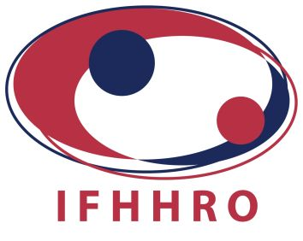
For training manuals specifically for health workers:
http://www.ifhhro-training-manual.org/index.php?r=site/show&id=9

The People’s Health Movement (PHM)
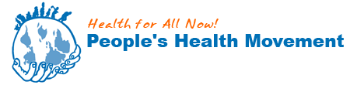
Health resources are listed:
http://www.phmovement.org/en/publications

The University of Cape Town OpenContent
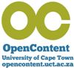
A training manual used in Train the Trainer courses for African health professionals since 1998 is available as an Open Educational Resource from the University of Cape Town
BALDWIN-RAGAVEN L AND LONDON L. 2010. Training Trainers for Health and Human Rights.
http://web.uct.ac.za/depts/hhr/documents/Train%20the%20trainers%20Manual%20edition%201.pdf

Human Rights Centre, University of Minnesota hosts an online library
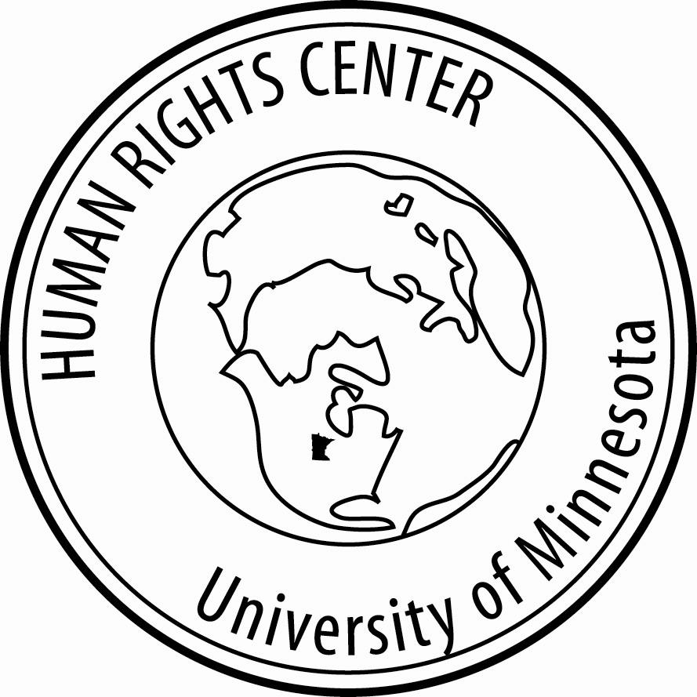
http://www1.umn.edu/humanrts/center/default.html

Media
The media influence public opinion contributing towards change.
Sharing personal stories is a powerful means for promoting human rights. For example Panos London aim to promote dialogue, debate and change. Their media pack titled Breaking Barriers: Women in a Man’s World, provides illuminating narratives of women taking on traditional men’s roles in 8 countries - inspiring for change toward sustainable development.
http://www.panos.org.uk/download.php?id=1080

NGOs

Médecins Sans Frontières (MSF) is an independent humanitarian organization working across international borders.

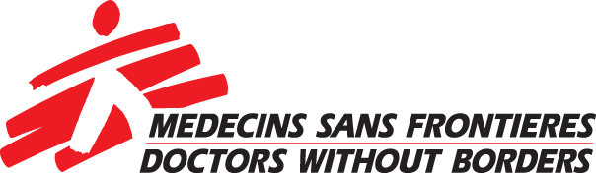

In the Democratic Republic of Congo, MSF supplied emergency medical treatment to 33 women who were raped in an organized attack on January 1st 2011. Fear and stigma deter these women seeking assistance.
http://www.doctorswithoutborders.org/aboutus/?ref=main-menu

Physicians for Human Rights (PHR) is an independent organization that aims to prevent human rights violations of individuals and populations. The professionalism and scientific expertise of medical personnel can make an important contribution towards the prevention and protection of human rights.
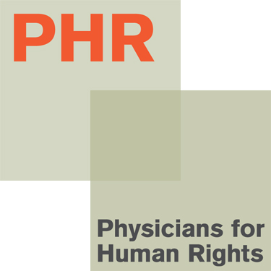
.http://physiciansforhumanrights.org/

Education

Learning for and about human rights can change the lives of those in training and others in their communities through a multiplier effect.

A highly successful human rights education project by Women for Women’s Human Rights – New Ways (WWHR) in Turkey, educates women, raising their awareness of their rights in a traditionally patriarchal society. A multiplier effect expands the impact of the educational project increasing capacity for social change.
http://www.wwhr.org/hrep.php

A focus on education for women and girls is demonstrated in India’s Kerala model of health – particularly beneficial for maternal and child health
http://india.gov.in/knowindia/health_kerala.php

Obstacles

Barriers to realizing and exercising human rights may be created by cultures and traditions that rationalize human rights violations such as patriarchal beliefs that women’s jobs are homebound. Such gender attitudes may limit opportunities for girls to gain an education promoting drop-out rates from schools.

WEE, V & SHAHEED, F. 2008. Women empowering themselves: A framework that interrogates and transforms. Women’s empowerment in Muslim contexts.
http://www.wemc.com.hk/web/rf/3_WEMC_Research_Framework.pdf

Standing up and speaking out for human rights can be dangerous
For instance a Mexican human rights defender was murdered in 2010.
http://www.globalfundforwomen.org/take-action/campaigns/104-general/1845-gfw-statement-on-the-murder-of-marisela-escobedo-ortiz

Local (South African) Key

Global influences

Climate change impacts on people’s livelihood and health. The influence of global warming, limited water supplies and unusual weather patterns is particularly felt by those most vulnerable. The World Health Organization has shown a correlation between mortality and climate change demonstrating the high mortality rates in Africa in contrast with other continents.
http://www.who.int/heli/risks/climate/climatechange/en/

National

Universal access to anti-retroviral therapy was promoted by the Treatment Action Campaign seeking judgement in the South African Constitutional Court. The State was ordered to make nevirapine available to all pregnant HIV positive mothers rather than a select few
http://www.right-to-education.org/node/661

MINISTER OF HEALTH AND OTHERS V TREATMENT ACTION CAMPAIGN AND OTHERS (2002) (5) SA 721 (CC), 2002 (10) BCLR 1033 (CC). http://www.saflii.org.za/za/cases/ZACC/2002/15.html

Family & community

In the Western Cape fruit growing area, a traditional long-standing practice of paying farm workers with rations of alcohol is known as the DOP system. Beyond limiting the wages earned by the workers, this practice promotes a dependence on alcohol persisting and permeating through generations within the local communities. A cycle of poverty is maintained leading to detrimental consequences such as domestic violence and foetal alcohol syndrome as explained in a case study called Dop till you Drop.

LONDON L. 2003. Human Rights, Environmental Justice, and the Health of Farm Workers in South Africa. International Journal of Occupational and Environmental Health.
9:1:61. Abstract at http://www.ijoeh.com/index.php/ijoeh/article/viewArticle/32

Fact sheet on alcohol abuse in SA from SA Health Info
http://www.sahealthinfo.org/admodule/alcohol.htm

Knowledge

Knowledge and understanding of the legal instruments protecting the rights of South Africans guides the State to respect, protect, promote and fulfil its human rights obligations for all. However despite the progressive legal provisions, operationalization of the theory is problematic in practice. Rights are frequently violated especially with vulnerable groups such as women. A conscious awareness of rights realities contributes to advancing the right to health.

The high level of societal violence influences social norms that infringe on the human rights of many people in communities. Knowing about and collaboratively working with non-governmental organizations contributes to the realization of human rights for all.

Human rights violations are prevalent.
Every 6 hours a woman in South Africa is killed by an intimate partner.
MATHEWS S, ABRAHAMS N, MARTIN L, VETTEN L, VAN DER MERWE L, JEWKES R. (2004) Every six hours a woman is killed by her intimate partner. A National Study of Female Homicide in South Africa. Medical Research Council. http://www.mrc.ac.za/policybriefs/woman.pdf

Empathy

Understanding the situation of others enlightens a human rights-based approach.
The HIV/Aids epidemic is challenging many policies and practices. For instance research on provider-initiated HIV testing for pregnant women in the ante-natal clinics indicated incidents of coercion without opportunity for voluntary decision making. Improved communication between providers and their clients respecting the rights of women to informed consent could help to avoid violation of their rights as indicated in the research report by the Aids Legal Network.

KEHLER J. et al. 2010. Where are the Human Rights for Pregnant Women? Scale-up of provider-initiated HIV testing and counselling of pregnant women:
The South African experience. Published by AIDS Legal Network. Cape Town. http://www.aln.org.za/downloads/HIV%20Testing%20in%20Pregnancy%20Report.pdf

Reflection

Critical reflection of the past to face the present and the future is an imperative to facilitate a transformative approach to healthcare, particularly in South Africa. While accountability of professional practice promotes respect for human rights, a conscious self-awareness of personal positioning is also important.

BALDWIN-RAGAVAN L, LONDON L, DE GRUCHY J. 2000. Learning from our apartheid past: Human rights challenges for health professionals in contemporary South Africa. Ethnicity and Health 5.3:227-241.
Abstract available at http://bases.bireme.br/cgi-bin/wxislind.exe/iah/online/?IsisScript=iah/iah.xis&nextAction=lnk&base=MEDLINE&exprSearch=11105266&indexSearch=UI&lang=i

Integrated Health Professional

An integrated approach to clinical practice promotes professionalism which in turn enhances human rights.

OLCKERS, L., GIBBS, T, & DUNCAN, M. 2007. Developing health science students into integrated professionals: A practical tool for learning. BMC Medical Education 7:45. http://www.ncbi.nlm.nih.gov/pmc/articles/PMC2186307/

Media

Attitudes and behaviours of populations are influenced by media messages.
Social networks and the internet contribute to greater scope for a collective voice. A call to remove Bishop Tutu as the patron of the Cape Town Holocaust Centre led to a counter petition over the internet supported by thousands of people worldwide.
http://www.news24.com/SouthAfrica/News/Tutu-petition-work-of-individuals-Federation-20110113

Non-Governmental Organizations

SECTION27 was established in May 2010. It incorporates the AIDS Law Project, one of South Africa’s most successful post-apartheid human rights organizations. SECTION27 is a public interest law centre that seeks to influence, develop and use the law to protect, promote and advance human rights.
http://www.section27.org.za/

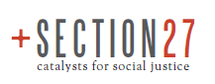

The Tshwaranang Legal Advocacy Centre (TLAC) was established in 1996 to eradicate the victimization of women by the legal system, and to make the law a vehicle of social change for women.
http://www.tlac.org.za/index.php?option=com_content&task=view&id=13&Itemid=162

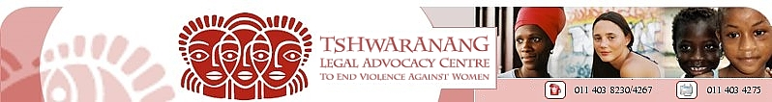

Sonke Gender Justice Network focuses on the role of men and boys to respect human rights by contributing to gender equality, prevention of gender based violence and reducing the spread of HIV.
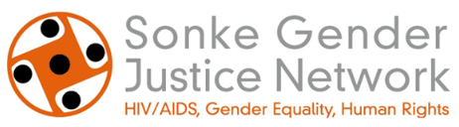
http://www.genderjustice.org.za/
Based in South Africa, their work is spreading through the African continent as indicated in their online documentary film in which people share their personal stories and commitment to promoting social change.
http://vimeo.com/26553725

Education

At school
Introducing human rights into school curricula as an obligatory subject was a priority for the new South African Government in 1994. To promote transformation the national Department of Education developed learning outcomes related to human rights awareness and responsibilities, appreciation of human rights principles, values and attitudes, and knowledge of citizenship and governance issues.
http://www.jsse.org/2006/2006-1/keet-carrim-s-africa.htm

At university
The Health Professional Council of South Africa (HPCSA) asserts to the need for professionals to respect human rights in their ethical practices. Undergraduate training ought to prepare students for adopting a human rights based approach to health.
http://www.hpcsa.co.za/downloads/conduct_ethics/rules/generic_ethical_rules/booklet_1_guidelines_good_prac.pdf

Obstacles

The legacy of Apartheid contributes to the barriers to access health care faced by many people in South Africa. Weaker health systems in rural areas, further exacerbated by high levels of poverty contribute to the obstacles faced by the majority of the population.
The South African Human Rights Commission (SAHRC) held a public inquiry in 2007. Their report (2009) indicated severe impediments to the realization of the right to health.
http://www.info.gov.za/view/DownloadFileAction?id=99769
For instance despite the implementation of the Choice on Termination of Pregnancy Act (No. 92 of 1996), only 50 % of designated facilities were operational - these were mostly in urban areas.
http://www.sangonet.org.za/article/sa-healthcare-system-failing

A research report by Human Rights Watch (2011) titled, Stop making excuses” describes cases of abuse in the Eastern Cape. Unhelpful attitudes of health care providers and poor accountability mechanisms in the health system deprive women of their right to access quality health care, influencing the increasing maternal mortality rates.
http://www.hrw.org/reports/2011/08/08/stop-making-excuses-0

Disability Key

Global

Over 650 million people worldwide live with disabilities constituting the largest minority population.

The World Report on Disability (2011) seeks to illuminate a holistic perspective on disability providing information on the economic, social, political and cultural factors impacting on the lives of this vulnerable group. Mainstreaming disability is an important component of sustainable development.
http://whqlibdoc.who.int/publications/2011/9789240685215_eng.pdf

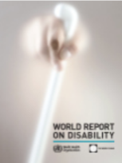

A case study in the city of Curitiba, Brazil illustrates the value of an enabling environment in which a universal design is implemented in planning and developing public transport facilities. This integrated transport system supports seamless transfers with raised platforms. Colour coding of the different routes assists people with sensory and cognitive impairments to freely use the facilities.

Accessibility is one of the general principles of the CRPD (Art.3) and mandates throughout the text of the Convention. Art.9 specifically guides provision for physical accessibility.

National

- Disparities in the health status of different countries may be amplified when related to disability and development issues.

For instance in developing countries, facilities and services for people with mental health impairments tend to be limited. Responding to the need for improvement in Africa, the newly established Centre for Public Mental Health (CPMH) is a collaborative initiative (with four African countries) to develop capacity through research and teaching to promote and strengthen public mental health.
http://mak.ac.ug/documents/SUNCPMHBrochure.pdf

- Universal access is a prime concern and obligation for States that have ratified the CRPD.

Recent efforts to promote inclusivity in South Africa include expanding options of accessibility.
The right to vote is fundamental yet many people with disabilities are denied this opportunity to express their civic choice. It was only in the 2011 local government elections that the South African Independent Electorate Commission (IEC) introduced tactile voting templates for people with visual disabilities, as explained by the Southern African NGO Network (SANGONeT) electronic newsletter, Sangonet Pulse.
http://www.ngopulse.org/press-release/iec-implements-tactile-template-increased-democratic-processes-2011-elections

Community and family

- Disability is a cross-cutting issue that increases individual’s vulnerability.
People with disabilities are more susceptible to violence, especially women and children. Art.16 (CRPD) provides for the right to freedom from exploitation, violence and abuse. Gender-based violence is especially prevalent amongst women and girls with disabilities as explained in a project by the Advocates for Human Rights.
http://stopvaw.org/Women_with_Disabilities.html

- Stigma and discrimination within communities, fuelled by negative attitudes and beliefs about disability may lead to social isolation, disadvantage and exclusion. A child may be deprived of educational opportunities due to the family’s understanding of disability as a curse and punishment. The best interests of the child may be ignored.

In Senegal reports of incidents of such violations of children’s rights indicate the importance of raising awareness on disability rights.
http://www.unhcr.org/refworld/publisher,IRIN,,SEN,4c64f1061e,0.html

Knowledge

Governments’ obligations laid out in policy frameworks give guidance to respect, protect, fulfill and promote the human rights of PWD. For example the provision of disability grants through social development departments is an essential component of States’ responsibilities.

- Exposure of violations is important to provide evidence for recourse. Complaints mechanisms ought to be clear and available to individuals and communities. National human rights institutions such as the South African Human Rights Commission (SAHRC) receive and act on complaints. Furthermore their role to oversee government’s accountability is important.
In the SAHRC’s public inquiry (2009) into access to the public health care services in South Africa, the implementation gap in realizing the right to access health care was revealed by indicating that the special needs of PWD were frequently disregarded. Examples of such violations occur when explanations for effective medication are unclear.
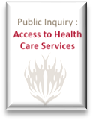
http://www.info.gov.za/view/DownloadFileAction?id=99769

- Empowering PWD through information to know their rights and to develop agency is crucial. Raising awareness of disability through reliable knowledge sources can assist in changing established negative perceptions.
The South African Disability Alliance (SADA) compromises 12 national organizations working in partnership to empower, engage and educate on disability – “unleashing unlimited potential”..
http://www.ibility.org.za/public/main/SADA.aspx

- Disability in Africa, Library, Documentation and Information Department provides a useful resource for information on disability http://www.ascleiden.nl/Library/Webdossiers/DisabilityInAfrica.aspx

- Knowledge about assistive devices and their availability can change lives. Art. 26 (CRPD) refers to States’ obligation to “promote the availability, knowledge and use of assistive devices and technologies”.

Examples in South Africa of commercial entities providing devices:

- For mobility:

- Shonaquip: Design and develop mobility devices to improve people’s functions and access to service, rights and opportunities.
http://www.shonaquip.co.za/

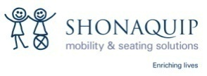
- For visual impairment, Access Technology is supported by:

    - Sensory Solutions: http://www.sensorysolutions.co.za/AboutUs.htm
    - Neville Clarence Technologies (Pty) Ltd
http://www.rsa-overseas.com/biz/general-business-links/770.htm

Empathy

- Supportive social relationships are particularly valued by PWD.
International support groups offer opportunities to share personal testimonies as a means of normalizing the challenges faced by PWD.

- The International Federation of Psoriasis Associations (IFPA), together with national and regional member associations, uses the personal stories of psoriasis sufferers from all over the world to help portray the true nature, and life burden, of this complex and difficult disease. This documentary project is called Under the Spotlight and is supported by health care provider Abbott.

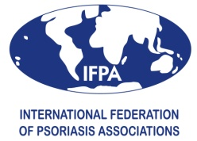
http://www.underthespotlight.com/

- Personal experiences drawn from young people can inspire more sensitive approaches to PWD

  - A Chicago student, Alixa demonstrates the value of non-judgementalism as she describes her story about “building bridges” in a project run by Facing the Past--Transforming Our Future.
http://www.facinghistory.org/about/who/profiles/chicago-student-turns-history-l

  - A YouTube video with background teaching notes depicts a school scenario where Tanya displays empathy towards her classmate Dylan who suffers from epilepsy while others are demeaning to him in his presence and on social media (produced by the Company of Angels for the Equality and Human Rights Commission, United Kingdom)
http://www.equalityhumanrights.com/advice-and-guidance/equal-rights-equal-respect/resource-toolkit/videos/video-1/

- Communication is key in developing respectful empathetic relationships. Past discourse on disability with terms such as “handicap”, “dumb” and “cripple” have undermined disabled people. A revised sensitivity to language promotes respect for human dignity avoiding inappropriate labelling that may discriminate and stigmatise groups and individuals as persons with disabilities (PWD).

Disabled People of South Africa (DPSA) developed A Pocket Guide on Disability Equity: an Empowerment Tool, to promote an understanding on the use of appropriate terminology that is not harmful to PWD. By engaging in respectful language use, revised values towards positive attitudes and social integration can enhance changes towards social integration.
http://www.dpsa.org.za/documents/pocketguide.php
.
Reflection

- Ignorance and fear about disability may lead to personal attitudes and beliefs detrimental to the advancement of the rights of PWD. Such thoughts, feelings and behaviours are enhanced by perpetuating myths and stereotypes. Becoming conscious of our own defence mechanisms to difference can promote disability rights. Such self-awareness and critical reflection may be valuable for PWD and the broader society.

Marlene Le Roux’s book and photo exhibition titled “Look at Me” thus aims to challenge traditional perceptions especially around sexuality and women with disabilities.
http://joho.book.co.za/blog/2009/08/13/marlene-le-rouxs-look-at-me-exhibition-set-for-uct-programme/

- Through complex photographic images, Angela Buckland portrays a range of emotions and experiences related to her son Nikki. By exposing the personal components of living with disability, she illuminates issues usually remaining invisible. Interactions with health professionals bring insight into understanding disability in professional practice.
McDougall, K., Swartz. L. & van der Merwe, A. 2006. Zip Zip My Brain Harts.
http://www.hsrcpress.ac.za/product.php?productid=2157

Star professional

Characterized by darkness and silence, disability seeks exposure – and enlightenment.

The star symbolism is significant for health care providers, who need to adapting to the ambiguities and uncertainties of PWD. Throwing light on the real lived experiences and needs of this vulnerable group is valuable. The star points to the multiple facets and approaches required to respect the dignity and freedom of PWD.

Media

- How the media represent disability has far reaching consequences, particularly the portrayed images related to masculinity and femininity.
Media and Disability’s website details the relationship of representation of disability in and by the media.
http://www.mediaanddisability.org/guide.htm

- Disability discourse is shaped and framed by media content, technologies and policies. The possibilities and tensions are discussed in Stadler’s chapter in the open source textbook, Disability and Social Change.
Stadler, J. 2006. Media and disability. In Disability and Social Change: A South African agenda. Watermeyer, B., Swartz, L., Lorenzo, T., Schneider, M. & Priestley, M. (eds).
http://www.hsrcpress.ac.za/product.php?productid=2151

- Advertisements for job opportunities for PWD are appearing on sites such as Women’sNet aiming to empower women towards social change.
http://www.womensnet.org.za/search/node/disability

- Social media provide new ways of sharing, overcoming frequently imposed limitations for people with sensory disabilities. Furthermore opportunities for collective action through petitions and awareness-raising become more inclusive for those with access to technology.

The BBC\s Facebook site Ouch! It’s a disability thing, offers an example of interactions through forums, blogs and newsletters.
http://www.bbc.co.uk/blogs/ouch/

NGOs

Non-governmental organizations and other civil society organizations provide valuable avenues to assist PWD realizing their rights. By collective action and solidarity to promote advocacy, pressure may be placed on governments to progressively realize their obligations.

Partnerships are crucially important as indicated by the popular slogan: “Nothing about us without us” - a commitment to participation and collaborative efforts related to disability.

One of the strengths of the CRPD is the responsibility of States to implement and monitor the operationalization of the convention promoting their accountability. Article 33 aims to narrow the implementation gap - setting a new precedent in the introduction of domestic measures for implementation, monitoring and evaluation mechanisms in operationalizing the CRPD.

- An international NGO, Mental Disability Advocacy Center advances the rights of individuals with intellectual disabilities and psycho-social disabilities. A summary of the cases they have brought before the European Court of Human Rights is available at
http://mdac.info/sites/mdac.info/files/English_Summaries%20of%20Mental%20Disability%20Cases%20Decided%20by%20the%20European%20Court%20of%20Human%20Rights.pdf
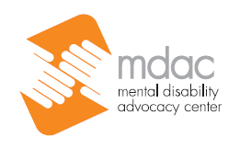

- Epilepsy South Africa aim to promote social change by empowering those with epilepsy and others. Their slogan “Changing obstacles into true potential” provides a powerful message. Online support and job opportunity advertisements are mechanisms used to build the capacity and capability of those affected by epilepsy.
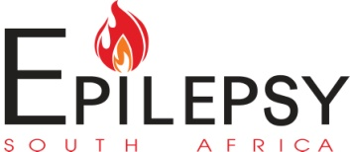

Education

Education and awareness are crucial elements in progressively realizing the rights of persons with disabilities.

- The United Nations Enable website highlights disability issues
http://www.un.org/disabilities/
- The University of Minnesota Human Rights Centre’s publication “Human Rights, YES” aims to promote effective education and advocacy for and about disability.
http://www.humanrightsyes.org

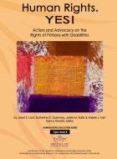
http://www1.umn.edu/humanrts/edumat/hreduseries/TB6/html/Copyright.html

- A vision and mission for transformation at the University of Cape Town (UCT) includes a Disability Service aiming to promote equity and excellence by providing technological assistance to meet the needs of students and staff with disabilities. Furthermore a Resource Centre provides literature on disability for research and general interest.
http://www.uct.ac.za/services/disability/

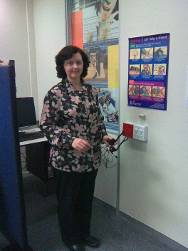

Denise Oldham (2011) manages the Disability Service computer lab at UCT

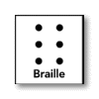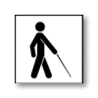

DISABILITY SERVICE
Promoting Access and Developing Solutions

Obstacles

Discrimination on the grounds of disability is common. Art.5 (CRPD) expresses the need for equality and non-discrimination through special measures such as reasonable accommodation. However, the presence of multiple obstacles and barriers impede the enjoyment PWD’s rights. It is imperative for States to adhere to the guidelines set out by the convention.

- Dr Marion Heap points out the language barriers present when members of the deaf community seek health care. Writing to the Cape Times newspaper, she motivates for change.
http://www.bhfglobal.com/healthcare-compromised-lack-interpreters-18-june-2008

Establishing national focal points (Art. 33. CRPD) ought to be a step towards overcoming frequent challenges faced by many people. South Africa established a national Office on the Status of Disabled Persons (OSDP) aiming to mainstream disability into all sectors of society through co-ordinated efforts rather than a fragmented approach.

Links between poverty and disability exacerbate the limitations imposed by disability for developing capacity towards the realization of rights. Evidence of this association is explained in a collaborative research project titled, Understanding poverty and disability in Johannesburg (2010) by authors at Johannesburg University, Centre for social development in Africa and the United Kingdom, Department for International Development.
http://www.uj.ac.za/EN/Faculties/humanities/researchcentres/csda/research/Documents/Poverty%20Disability%20Content%202010%20A5.pdf

